*Interval During Lockdown Period Unlock Predictor Using Python*

*End Term Project*

*By*

*Names:* Errappagouni Harshith,

Vepanjeri Yaswanth,

Sweety Kumari.

Section: K19Qw

Roll Numbers: 29, 28,39

Department Of Intelligent Systems,

School Of Computer Science Engineering,

Lovely Professional University, Jalandhar

November, 2020

Student Declaration

This is to declare that this report has been written by me/us. No part of the report is copied from other sources. All information included from other sources have been duely acknowledged. I/we aver that if any part of the report is found to be copied, I/we are shall take full responsibility for it

Signature:

Name:

Roll Number:

Place:

Date:

Table Of Contents

Title PageNo

1. Background and objectives of project assigned.

1.1 Introduction

1.2 Objectives

1. Need of this project
2. Description
3. Language used

**Introduction**

Since, December 2019, a pneumonia infection broke out in Wuhan, Hubei province and spread in entire China and many other countries. Chinese health authorities observed notoriously a cluster of pneumonia cases of unknown aetiology.[1](https://www.ncbi.nlm.nih.gov/pmc/articles/PMC7308770/#bib1) Relations between the key cases and the city's South China Sea food market were found. The chance of another zoonosis or severe acute respiratory syndrome (SARS) outbreak was at the top of the priority, investigations were attempted which result in recognition of a novel coronavirus, SARS-CoV-2 (formerly 2019-nCoV), as the agent has entered as international outbreak in Hubei. China has revealed total of 72,528 confirmed cases till February 17, 2020.[2](https://www.ncbi.nlm.nih.gov/pmc/articles/PMC7308770/#bib2) , [3](https://www.ncbi.nlm.nih.gov/pmc/articles/PMC7308770/#bib3) The novel coronavirus 2019 (COVID-19) has spread across 210 nations and regions with 1.2 million confirmed cases and 67594 deaths reported on April 6, 2020. The WHO declared public health as an emergency at international level. The worldwide community gets worried about COVID-19 and its impact on public health. WHO is trying to control the impact of pandemic through identification, testing, treatment of patients, clinical trials for drugs and development of new vaccines.[4](https://www.ncbi.nlm.nih.gov/pmc/articles/PMC7308770/#bib4) In India, first case of COVID -19 was reported on January 30, 2020 who returned from Wuhan, China. Considering the first case as a matter of great worry, screening of traveller at airport had been started, immediately Chinese visas had been cancelled, and people who were found affected with COVID-19 had been quarantined.[5](https://www.ncbi.nlm.nih.gov/pmc/articles/PMC7308770/#bib5)

The Ministry of Health and Family Welfare (MoHFW) of India had primarily warned to avoid travelling to China and advised quarantine of those returning from China.[6](https://www.ncbi.nlm.nih.gov/pmc/articles/PMC7308770/#bib6) However, India is at high risk forbeing the second highest populated country in the world. Most of the studies show the prediction of COVID -19 through modeling for growth of infected population. In the absence of a licensed vaccine or effective therapeutics for COVID-19, other advises from hand cleanliness to quarantine, a basic strategy to control spread of epidemic and alleviation mediation towards the early detection and quarantine of cases can break the chain of transmission. The SARS-CoV-2 pandemic is currently a great challenge for researchers, clinicians, health-care workers, and decision makers. We depict the most striking difficulties for statisticians who need to provide support in this pandemic with their proficiency. Having a knowledge of the dynamics of case load rate and recovery rate of COVID-19 can enhance the basic understanding to a large extent based on the current patterns of the severity of the epidemic. As COVID-19 cases are increasing day-by-day, case load rate will be of utmost importance in predicting the declination of the epidemic. In this article, we want to predict the date when the recovery rate of patients would be more than case load rate in India. This date is defined as disease declined date.

**Objectives**

The present study aimed to predict the declination of COVID-19 using recovery rate and case load rate on basis of available data from India.

**Need Of This Project**

This project helps us to find the number of cases registered in number of days and shows the graph of Covid-19 growth. So that we can calculate the number of cases registered in particular number of days and the growth of the Disease.

**Description**

The source code for the same project is uploaded in a python file, link of the same has been provided in the google forms submitted to the teacher.

Now we shall discuss the input and outputbof the code, so that we get a clearer idea of this project is going to work

Following is the initial screenshot of the code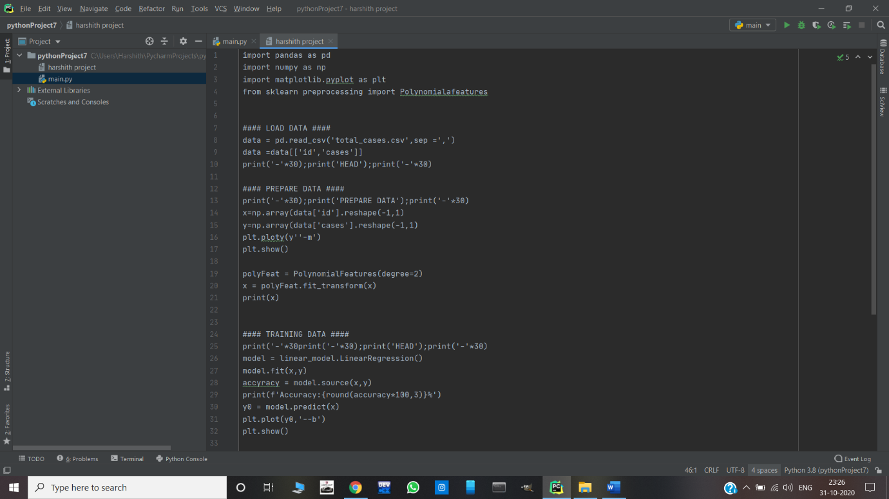

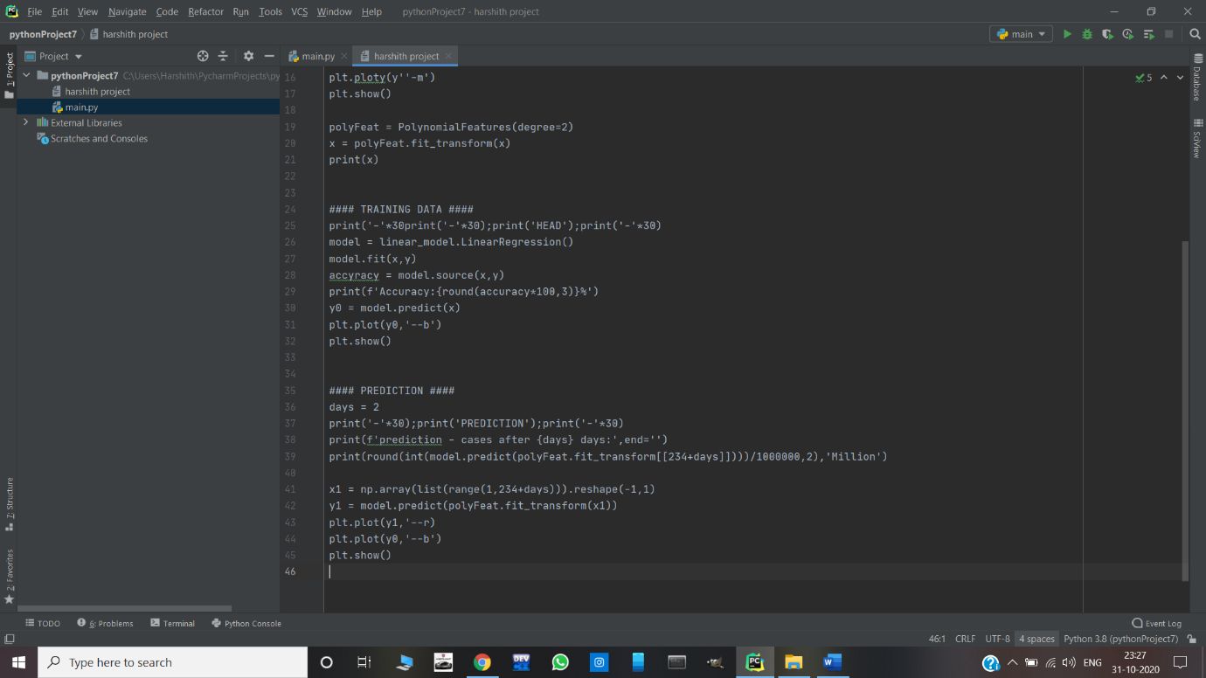

Enter the number of days that you want the information of

Out put of the code

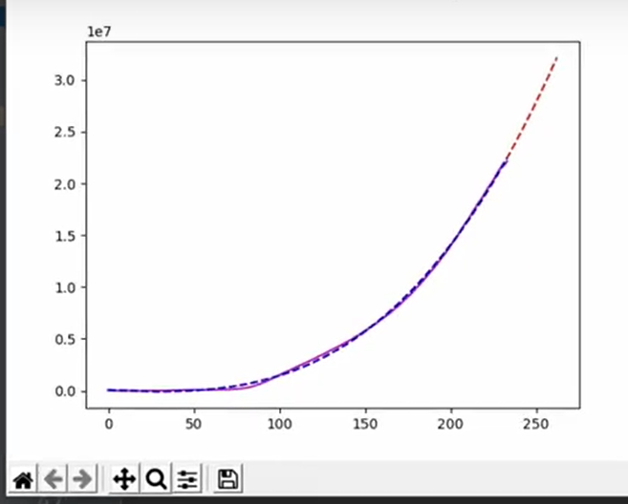

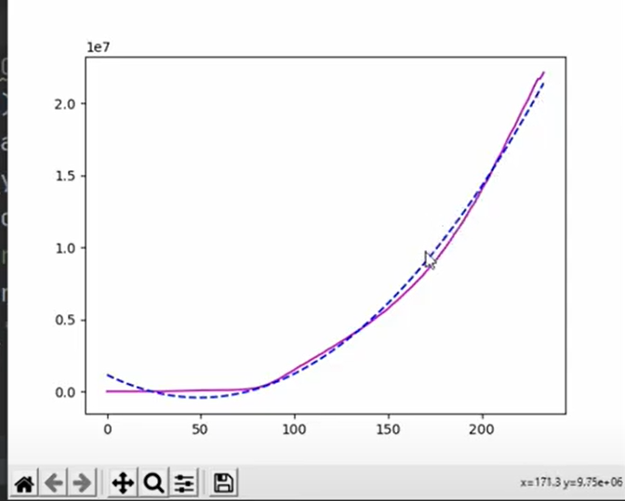

**Language used**

The language used is python due with no additional libraries. The IDE used as spyder(Anaconda).

Works Done By Members:

Harshith:- Did the coding and algorithmic part along GUI, and testing, also helped in making report.

Yaswanth:-Helped in finding errors and making code more optimised, also helped in making report.

Sweety:-Did report and helped in finding errors.

**Thankyou**